**Recipe Application Documentation**

**Naveen M  
Reg.no: 212222110029**

**Saveetha Engineering College**

**04/06/2025**

**1.** **Overview**

This project is a web-based recipe application that allows users to:

* Browse recipes stored in a SQLite database.
* Search and filter recipes by title and cuisine.
* Paginate results for easier navigation.
* View recipe details such as title, cuisine, rating, and description.
* The application consists of a Flask backend (serving a RESTful API and the frontend) and a modern, responsive frontend.
* The SQLite Database (**recipes.db**) has **8451** data

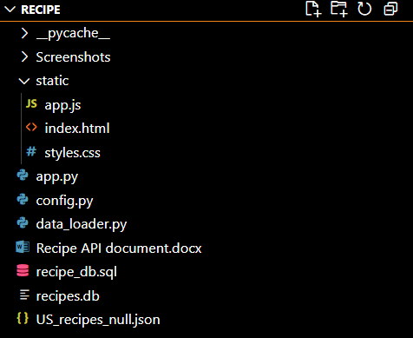**2.** **Project Structure**

**Key Points on Converting JSON to SQLite Database**

* Use sqlite3 to interact with the SQLite database and json to parse the JSON file
* Load the JSON data into Python using json.load()
* Establish a connection to the SQLite database file using sqlite3.connect()
* Define the table schema and create it using SQL CREATE TABLE
* Loop through each JSON object and insert its values into the SQLite table using INSERT statements
* Handle Data Types and Structure:
  + **Flat JSON:** Each key-value pair in the JSON object maps directly to a column in the table.
  + **Nested JSON:** Store nested objects or lists as JSON strings (using json.dumps()) or consider normalizing into separate tables

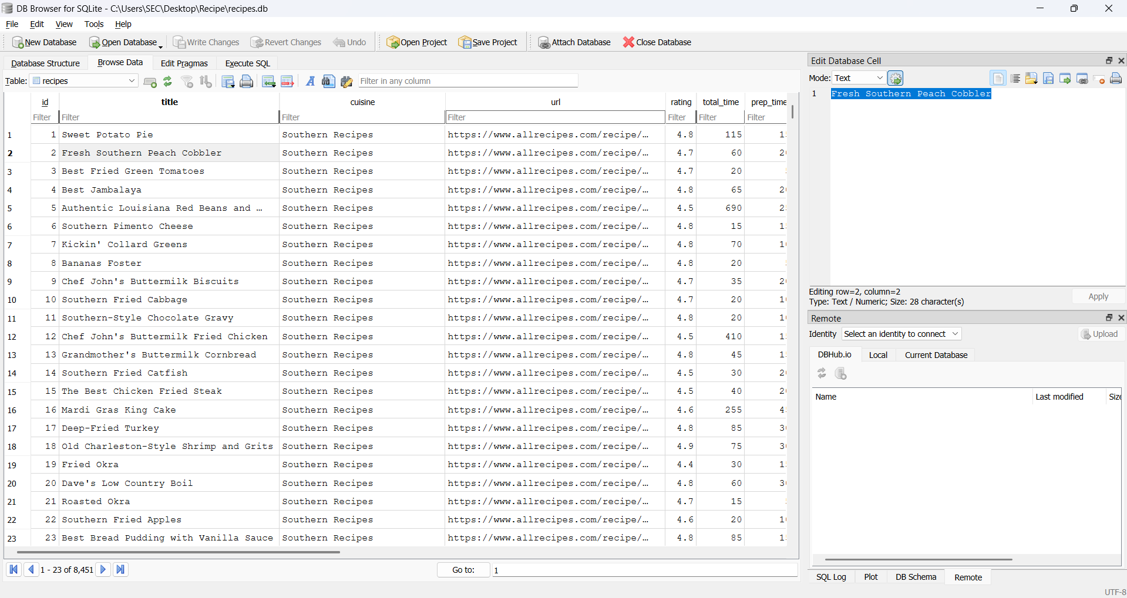

**3.** **System Requirements**

* Python 3
* Flask (pip install flask)
* SQLite3 (included with Python)
* Web browser (Chrome, Firefox, Edge, etc.)

**4**. **Setup**

4.1. Prepare the Database

Run the data loader script to populate the SQLite database from your JSON file.

The database file (**recipes.db)** will be created in your project folder.

4.2. Start the Flask Application

**python app.py**

This will start the server at http://localhost:5000.

**5. Frontend Features**

Search and Filter: Filter recipes by title and/or cuisine.

Pagination: Navigate through pages of recipes using page and limit controls.

Responsive Design: Works on desktop and mobile devices.

**6.** **Backend API Endpoints**

All endpoints are prefixed with /api/recipes

|  |  |
| --- | --- |
| **Endpoint** | **Method** |
| http://localhost:5000/api/recipes | GET |
| http://localhost:5000/api/recipes /title/Sweet%20Potato%20Pie | GET |
| http://localhost:5000/api/recipes/cuisine?cuisine=Southern%20Recipes | GET |
| http://localhost:5000/api/recipes?page=2&limit=5 | GET |

**7. How to Use**

Access the application:  
Open http://localhost:5000 in your browser.

Browse recipes:  
Recipes are displayed in a table. Use the filters to bar to get the results.

Paginate results:  
Use the page and limit inputs to navigate through pages.

Search and filter:  
Enter a title or cuisine to filter the results.

**8. Example API Requests**

Fetching all recipes:

**GET http://localhost:5000/api/recipes**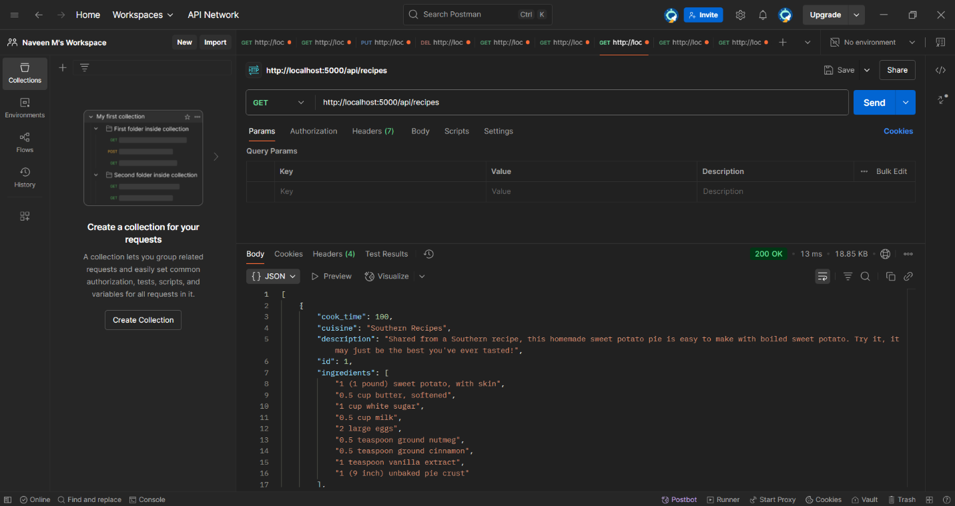

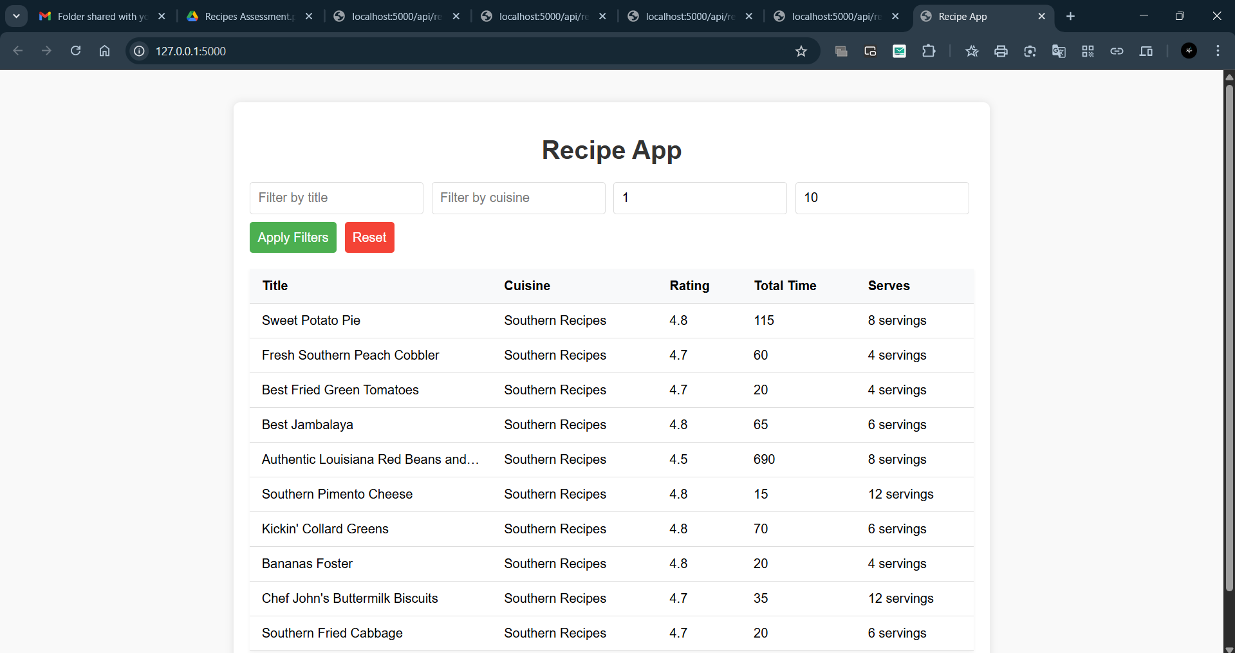

Search for "pie" in title and "American" cuisine:

GET /api/recipes/search?title=pie&cuisine= all recipes:

Searching by title:

**GET http://localhost:5000/api/recipes** **/title/Sweet%20Potato%20Pie**

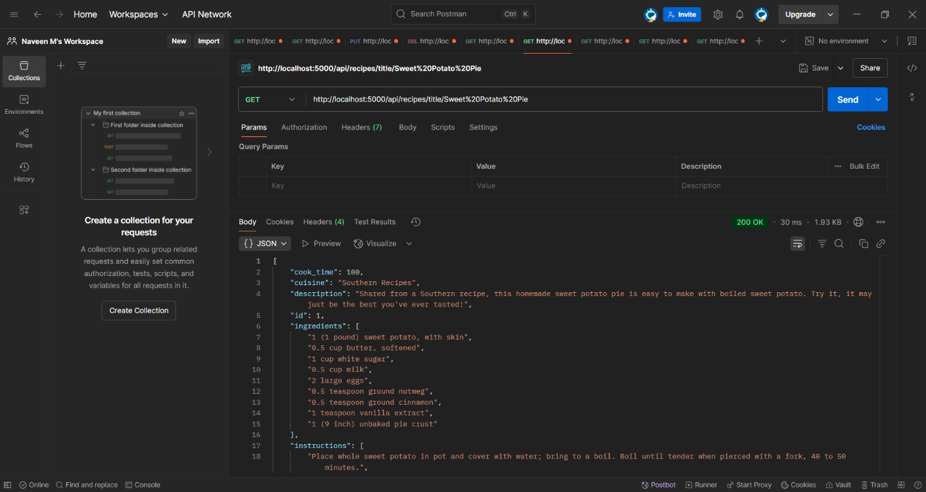

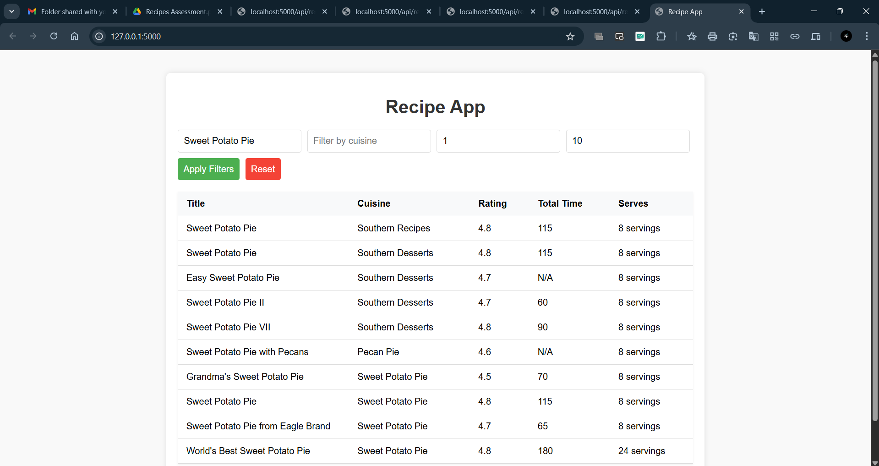

Searching by cuisine

**GET http://localhost:5000/api/recipes/cuisine?cuisine=Southern%20Recipes**

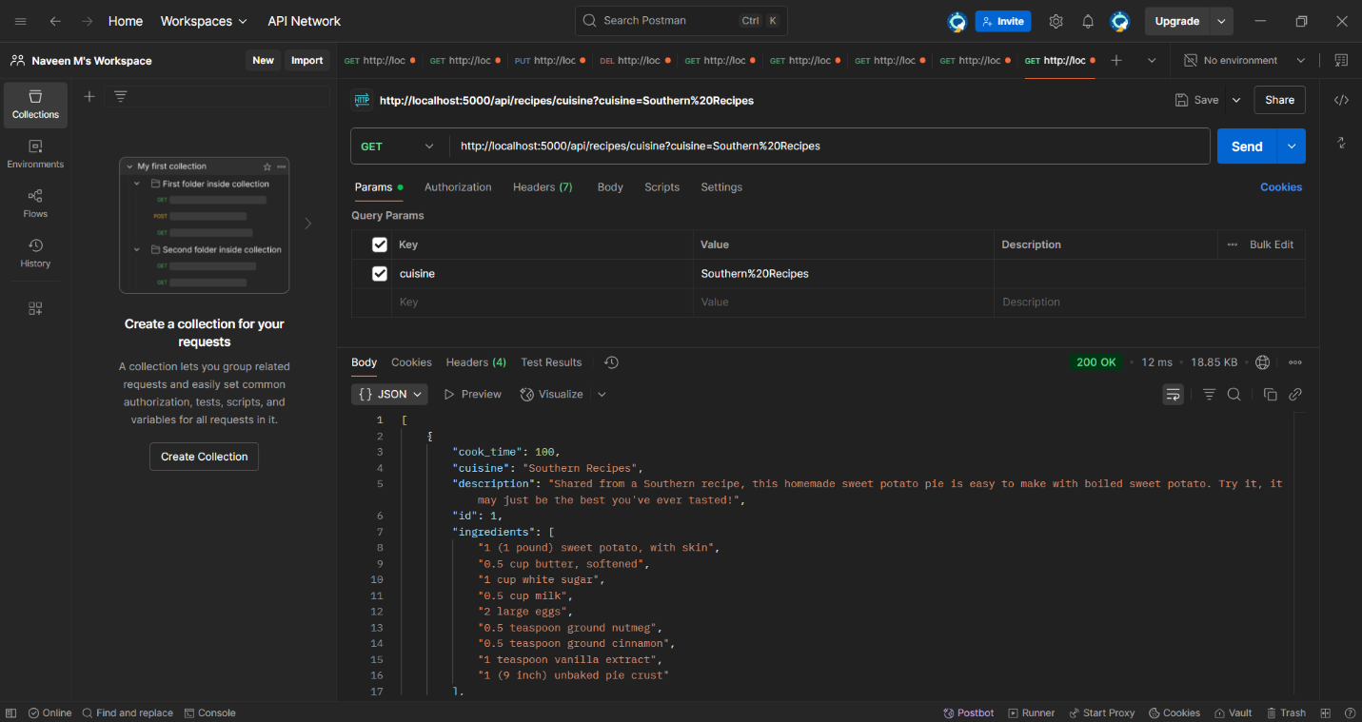

**10. Conclusion**

**Backend:**

Uses Flask for routing and API logic.

SQLite for data storage.

All JSON fields are stored as db and parsed back to objects in the API.

**Frontend:**

JavaScript for dynamic content.

Responsive CSS for all screen sizes.

Fetches data from the backend API using fetch.

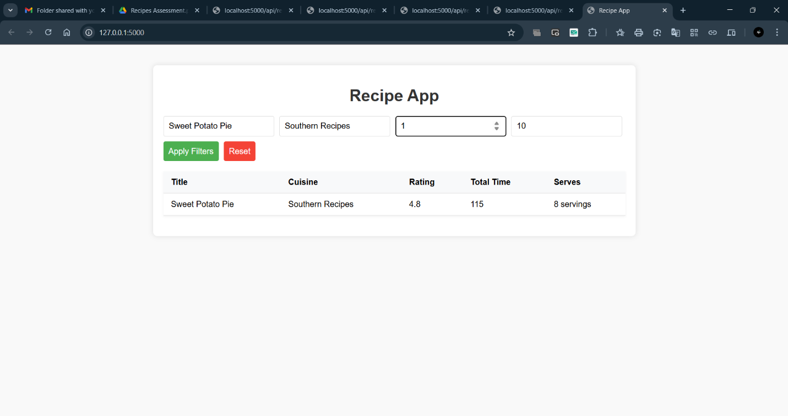

Page and Limiting

**GET http://localhost:5000/api/recipes?page=2&limit=5** 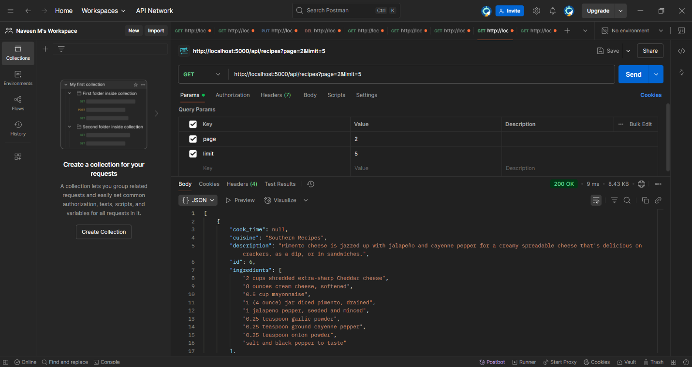

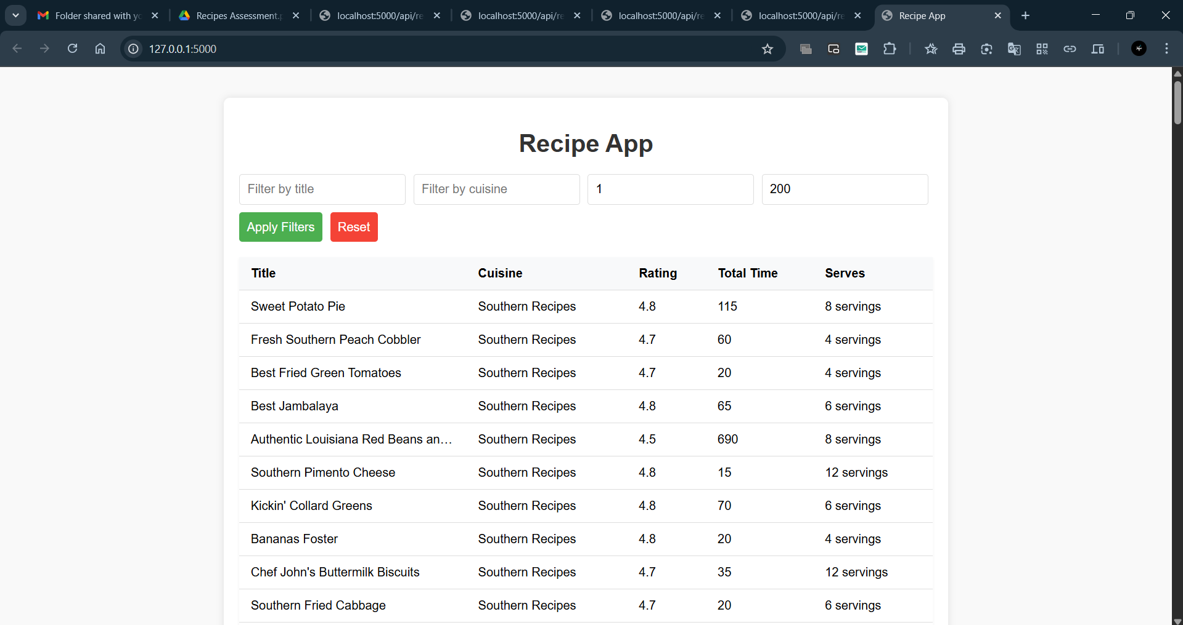

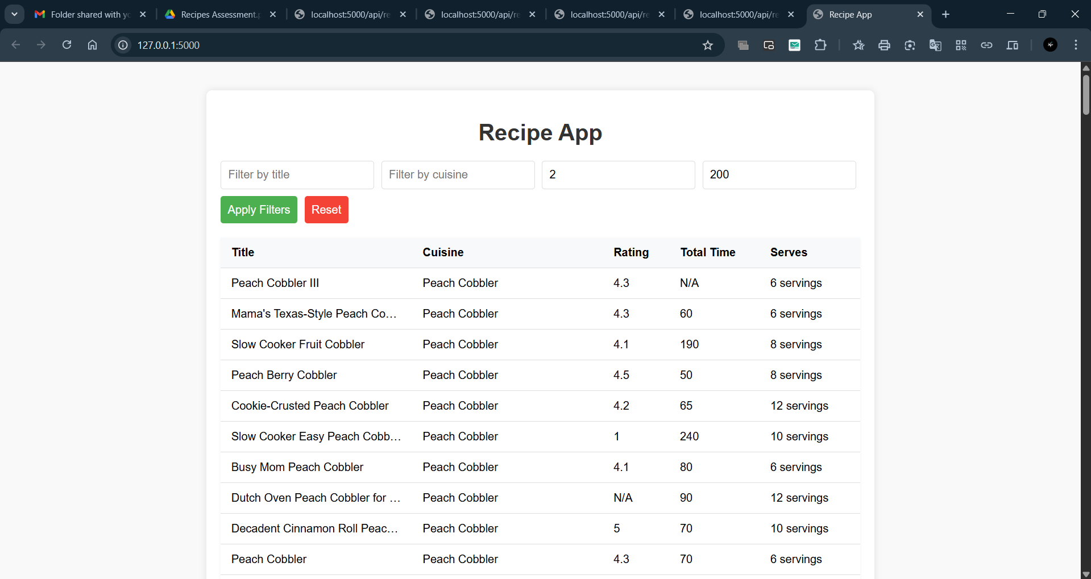

**9. Conclusion**

* **Backend:**
  + Uses Flask for routing and API logic.
  + SQLite for data storage.
  + All JSON fields are stored as db using SQLite and parsed back to objects in the API.
* **Frontend:**
  + JavaScript for dynamic content.
  + Responsive CSS for all screen sizes.
  + Fetches data from the backend API using fetch.